**REPORT ON LAUNCH OF THE PROJECT**

**‘’*Promoting Civic Participation in the Democratization Processes through Entertainment”***

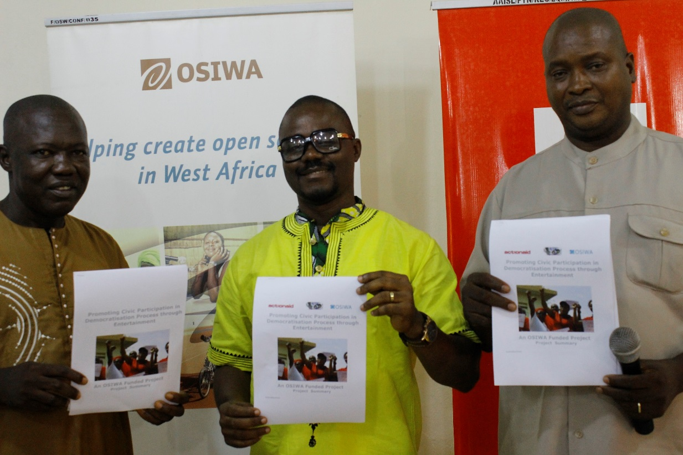

**22nd September 2017**

cid:image001.jpg@01D11D63.EE71FAB0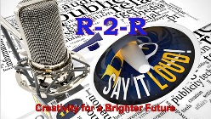

**INTRODUCTION**

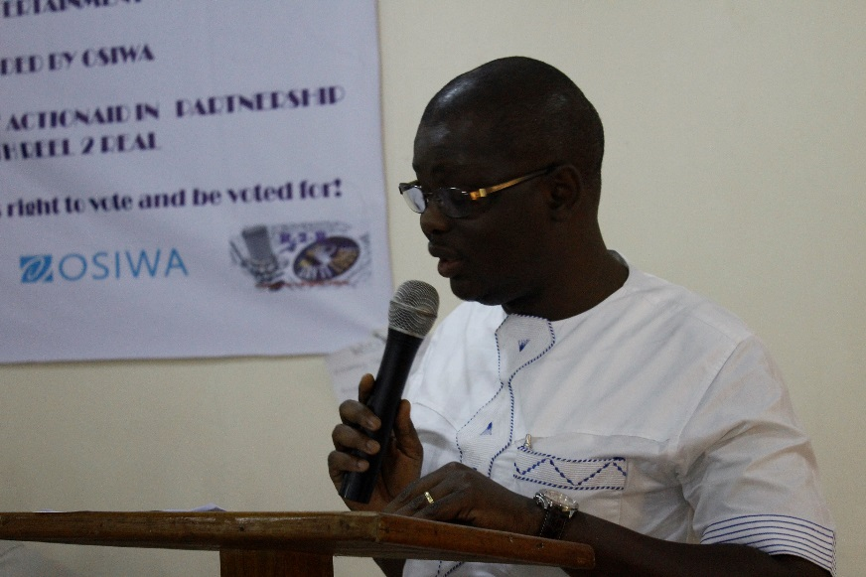The Republic of Sierra Leone has made considerable progress in consolidating peace, democracy and economic growth evidenced by what the international and local observers referred to as the “free and fair” elections in 2012 which ushered in the democratically elected government of President Ernest Bai Korma of the All People’s Congress Party (APC). Since the 2012 elections - the first democratic elections entered into after the eleven year devastating civil war; Sierra Leone continued to be classified as a fragile state which has the possibility of returning into conflict should governance processes such as elections were not properly managed.

As the nation gets ready for another general election in 2018, there is increase in citizens’ cautious interest and apprehension on one hand and the seeming electoral apathy on the other hand.

***Mohamed Sillah, Executive Director ActionAid.***

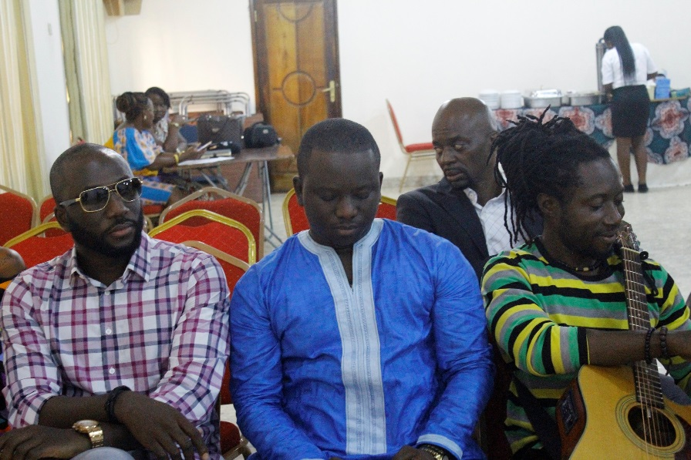It was against this background that in April 2017, ActionAid Sierra Leone (AASL) entered into a partnership with Open Society Initiatives for West African (OSIWA) to implement a project titled “***PROMOTING CIVIC PARTICIPATION IN DEMOCRATIZATION PROCESSES THROUGH ENTERTAINMENT’*** with the overall objective ***t***o promote civic participation in Sierra Leone’s 2018 Presidential, Parliamentary and local council elections with an improved understanding of and participation in non-violence electoral processes in Sierra Leone particularly among Women and Youths. **The project was submitted by Action in partnership with Reel 2 Real Entertainment**. Thus, ActionAid entered into partnership with Reel2Real for the effective implementation of the project. Initially, the project was envisaged to be implemented in four out of the 14 districts - **Western Area, Kenema, Bo, and Makeni but considering that t**here still remains a large proportion of the country that is unreached and also realizing that election is a democratic process and rights of every citizen, partners to the project saw it befits that this unique project be extended to the most marginalized districts and potential flashpoints that require structured civic engagement. A add on project was designed and submitted to cover six additional districts-  **Port Loko, Kailahun, Kambia, Kono, Moyamba and Koinadugu districts.**

***Emmerson Bockarie of Sugar Entertainment & Crew***

The project specific objectives are as follows:

* Position the entertainment industry to produce elections goodwill Ambassadors to engage citizens on civic education process.
* Enhance citizens power and participation particularly women, youths in the 2018 general and local elections.
* Facilitate young people to take an interest in the governance process in the country through online campaigns themed around peace, elections and good governance.

In a bid to achieve the above objectives series of activities were slated. Core among them was the launch of the project.

This report therefore is an outline of the launching process which was followed by the inception meeting for partners to the project.

**DESCRIPTION OF EVENTS**

**Project Launch**

The essence of the of the launch was forpartners and stakeholders and the general populace to get a clearer understanding of the project and to give visibility to kick start and to get the public interest in the implementation phase.

The inception was meant to for partners to get better understanding of what is expected of them during the project execution over the one year period and prepare for proper implementation.

The event took place at the Hill Valley Hotel and attracted fifty (eighty) representatives at the Hill Valley Hotel on Thursday 21st September 2017. Diverse stakeholders including elections Management bodies – the Police, PPRC and NEC were invited but only two turned up for the meeting. Interreligious Council, National Commission for Democracy (NCD) and the donor partner also attended. CS groups working on elections, youth groups, Activistas from 7 LRPs and artists were in attendance.

The specific objectives for the launch and inception was to organize a one day project launch and inception meeting by end of September 2017.

**Highlights of the Launch**

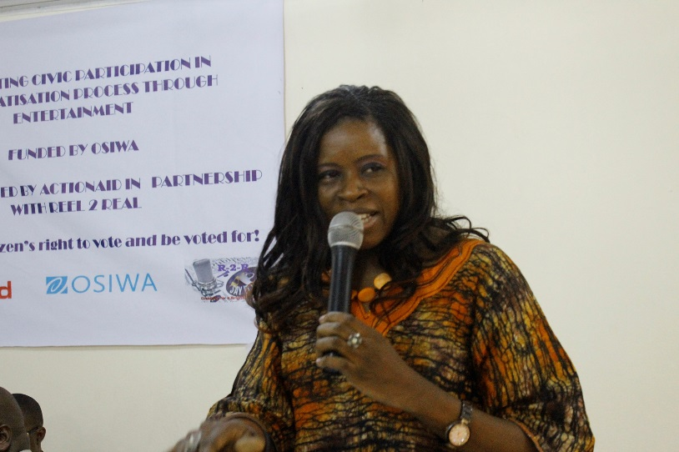

The meeting was called to order by Madam Zynab Senesie, Head of Fundraising who welcomed all the attendees for gracing the occasion. Special recognition was given to the team of Artist especially Emmerson Bockarie who travelled from Nigeria to be part of the launching ceremony.

The ceremony was chaired by Madam Valnora Edwin, Executive Director of the Campaign for Good Governance. In her opening remark she felt humbled for being asked to be part of the process as the project appeals to her organisation and the work they do. She was happy for the opportunity given to her to serve in such capacity, and meeting Emerson Bockarie once again.

***Valnora Edwin, Executive Director CGG***

Mr Mohamed Sillah, Executive Director, ActionAid gave the relevance and purpose of the project. In his remark he informed the meeting about the partnership between ActionAid Reel to Real with support from Open society Initiative for West African (OSIWA) for the implementation of the said project which is for one year six months – April – December 2018. He outlined the prevailing context that warranted the project design which he said was the increase in citizens’ cautious interest and apprehension on one hand and the seeming electoral apathy on the other hand; a situation which could only be limited through civic education to enhance citizens ’participation in a non-violence space come March 2018. He outlined the objectives of the project and the activities to be implemented which will include an extensive work with the entertainment industries – especially credible artist to take the lead to education the youth and women population which are in the large proportion on the democratic rights and responsibility across the 10 districts. He called on the activistas to put in their best to reach out in the course of the project to other youths to sensitise them to vote and to vote right. He concluded by thanking OSIWA for the support to the elections process and to Reel to Real and counterpart – Sugar Entertainment for being part of this project.

**Statements:**

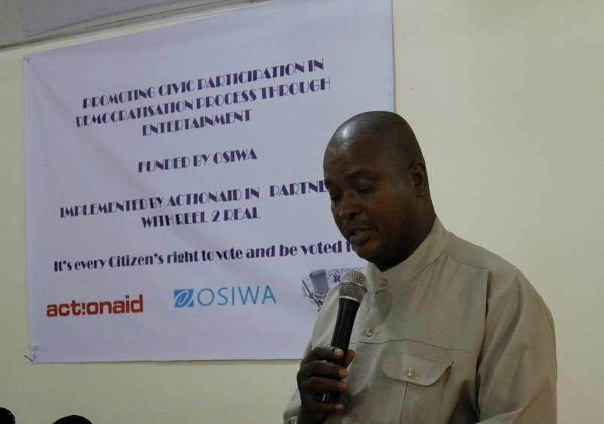**National Commission for Democracy (NCD)**

The Representative – Rev Gibrilla Kargbo, Communications and Public Relations Manager, NCD on behalf of the NCD extended warm felicitations to ActionAid Sierra Leone for the invitation to attend the launching ceremony of what he referred to as “very vital” project supported by OSIWA bordering around civic education for elections.

***Rev. Gibrilla Kargbo, Communications Manager, NCD***

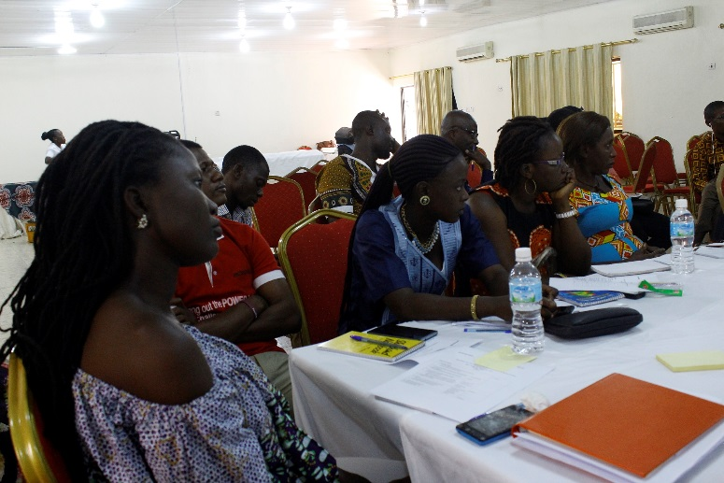He said the NCD were cognizant of the fact that though they have the statutory mandate of promoting positive participation of the general citizenry through Civic Education, the space should be opened up to create room for actors in order to enhance the democratization process in the country with room for effective collaboration especially between state and non-state actors as they bring together the interface between legality and the availability of resources through shared experiences and expertise that can lend a stronger voice to the process of improving on democratic gains and consolidating the nation’s democracy. He registered the importance of the project to be implemented by ActionAid Sierra Leone in collaboration with Reel2Real Entertainment Company as very glaring with far-reaching implications for the voting population especially young people and new voters.

He noted that it is now beyond the realm of conjecture that the March 7 2018 elections will provide an opportunity to test whether our governance institutions are well structured and are actually working. In this regard, he stated that it should be crystal clear to all that effective Civic Education is required from all directions in order to establish the right atmosphere for the peaceful and successful outcomes of the March 7 2018 poll. In other words, civic education is key to injecting free blood and thus invigorating the nation democracy.

He appealed to the patriotic and nationalistic instinct of the general citizenry to the effect that the full involvement of all and sundry in the forthcoming electoral process should be seen as both a civic right and responsibility for all should be strategically involved in granting entrance legitimacy to the next government that will rule the country for next five years.

There was need to deepen our democracy and strengthen the institutions of governance by our willingness to participate in the electoral and governance process in ways that ensures tolerance of divergent views and inclusivity of the various opinions.

Democracy provides the natural environment for the respect of human rights and the upholding of the rule of law, he noted and called on all to be willing to take a stand for democracy and continue with its promotion using various means or channels and as music has been a very amazing channel to communicate important messages especially of peace, unity and national cohesion in a multi-ethnic society where everyone is equal before the law and where all and sundry are ready to obey the law and change the development trajectory of the nation all by ourselves.

In conclusion, he assured ActionAid Sierra Leone that National Commission for Democracy was always ready and willing to work in promoting the common good of the nation we love and wished ActionAid the best in implementing this timely and appropriate project.

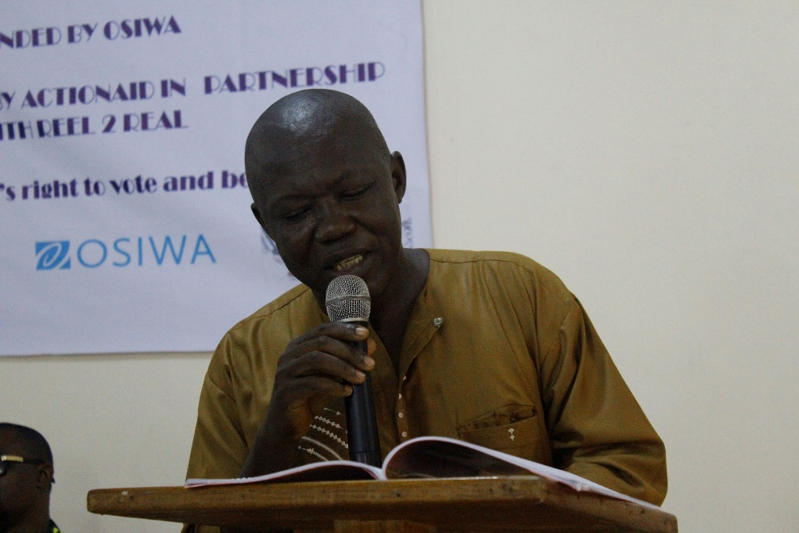**Interreligious Council of Sierra leone**

The Representative presented the IRCSL to the audience explaining its composition which is of two major religions in the country: Islam and Christianity, whose constituent is the highest among CSOs and other state actors adding that their organization exist as moral guarantor of peace and human dignity

He mentioned that IRCSL is aware that election has the potential to enhance peace dignity and build young democracies like ours while noting with dismay that elections in emerging democracies like in Africa has also undermined peace, dignity and democracy expressing the timeliness of the project .

***Inter-religious council member a statement***

IRCSL, the representative said will not hesitate to say that music is crucial for the process and that the church as an example is benefiting from music in terms of church growth. He therefor expressed the need for IRCSL collaboration with ActionAid in this move. He mentioned that they are looking for any kind of collaboration and assured all that they had a wider and listening constituency to take messages of civic education.

In conclusion, he cautioned the artist and the Activistas to note that music also has the potential to derail the electoral process. He said it was in a **song that sparked the strain relationship between David and** **Saul**. It is therefore important that we consider the content of the songs and the manner, gestures we make our music presentation. Songs are emotional and emotions can calm and influenced one’s feeling. Music is critical in every aspect of the electioneering process, but more critical in election celebrations, and encouraged the ***artists to make sure that their songs be neutral, impartial and non-partisan***.

**Sierra Leone Police**

The representative form the Sierra Leone Police on behalf of the Inspector General of Police extended her thanks for the invitation.

She informed the audience that the Sierra Leone Police is a responsible organization that is mindful of the fact that they are operating in a democratic setting; therefore, support any drive that promotes civic 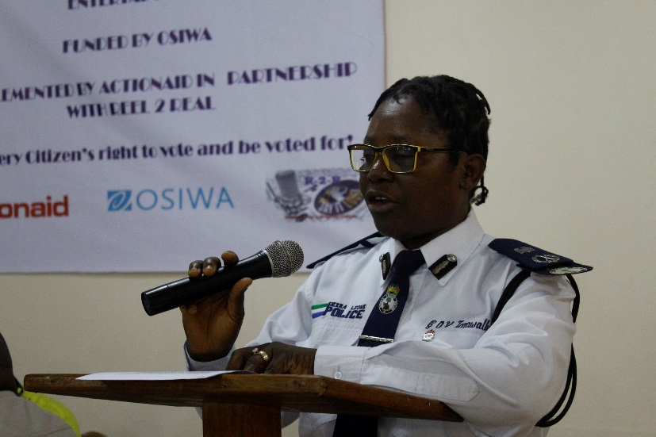participation in a democratization process in the country, they believed that this cannot be actualize in the midst of uncertainties and insecurity.

In retrospect she added, the SLP single handedly policed the 2004 and 2008 Local Government Council Elections, the 1996, 2002, 2007 presidential and parliamentary elections and the 2012 local and government council election, presidential and parliamentary elections. She noted, this recorded the great effort made by the police to consolidate peace, stability and democracy and pursue the path to sustainable development. She added that the international community applauded the SLP for the orderly and peaceful manner in which the whole exercise was conducted and even the overall security situation. ***She ensured that 2018 elections will not be different***.

***AIG. Tarawally making a statement of commitment.***

To demonstrate their readiness she outlined areas of focus including mobilization and sensitization of communities especially the youth to refrain from violence, misuse of drugs, clique activities; highlighting the roles and responsibilities of the people during the electioneering period. She informed the meeting that the country has been divided into zones, for easy access to remote areas and that they intend to print flyers and posters with peace and non-violence messages for distribution to police personnel and the general public. She further mentioned that they will partner with ***national and international music Artists and other entertainers to organize a big peace concert at the Siaka Stevens Stadium and the Regional Headquarter towns,*** which will be climaxed by a peace march which will involve all stakeholders to demonstrate the commitment of the SLP towards a free, fair, transparent, non-violence and peaceful elections.

***She pledged the commitment of the Sierra Leone Police on behalf of the Inspector General of Police***, the ***Executive and Board and the rank and file of the Sierra Leone Police to provide the enabling security environment for peaceful democratic elections in 2018***.

**National Elections Commission (NEC)**

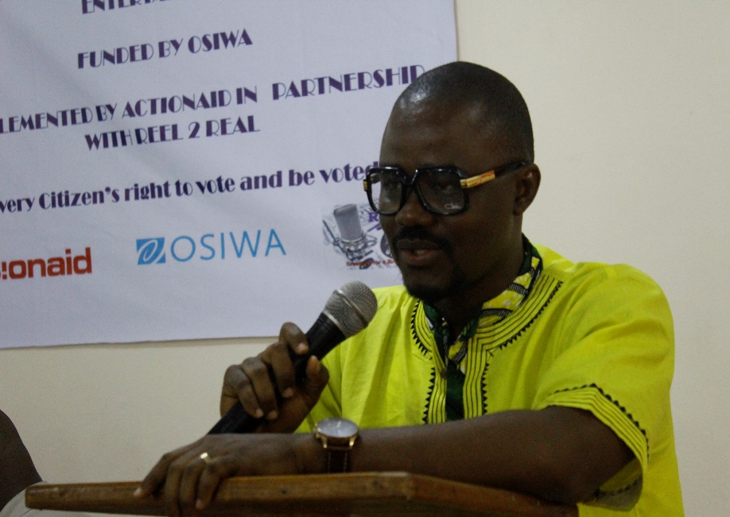The representative of NEC, Albert Massaquoi thanked ActionAid and OSIWA for the project which he said is to support NEC in its bid to conduct a free fair and credible elections. He explained the progress made so far in the Commission despite the challenges faced and gave assurance that the elections will take place March 7 2018. He outlined commitment and status of support to the elections process by Government and donor partners like UNDP and expressed hope that all will be met for a peaceful, free fair and credible elections. He mentioned that the Commission with support from UNDP will ensure the production of the voter ID card and that the PVR will not be produced in hard copies due to lack of fund. He informed the meeting that whiles UNDP has taken the major funding aspect which are the ID cards, yet there still challenges of education and logistics. He expressed confidence that the project will help to curb violence and support in sensitizing women and youths to actively participate in the elections process.

***Albert Massaquoi, PR NEC, Making a statement.***

He mentioned that the Commission’s area of interest in the election’s messaging and a value addition which should be consistent and should be factual. He explained their role which is to cross check, double check to maintain consistency in the messages that goes out to the public domain

Albert in conclusion, expressed commitment of the Commission to partner with ActionAid and OSIWA in this project across the country.

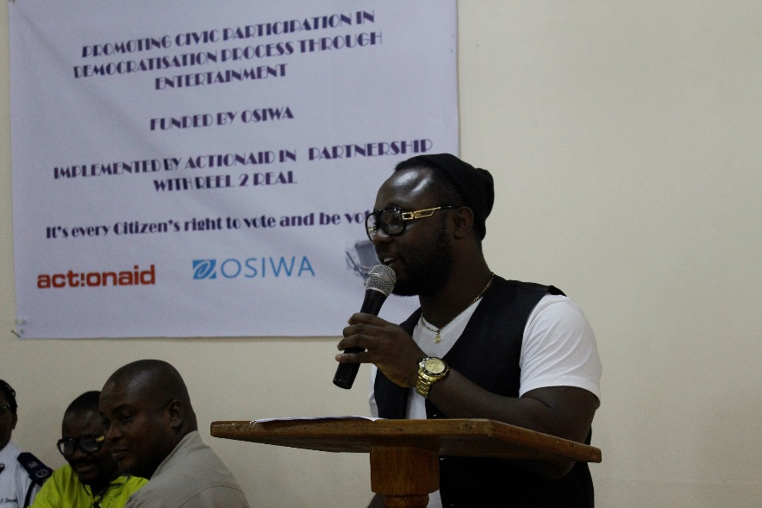***Reel2 Real***

Wahid, a representative of Artists for Peace in making his statement on behalf of R2R expressed joy for being part of the project. He explained that R2R has produced many artist like Emmerson Bockarie, Steady Bongo etc and that their role is to use entertainment to educate citizens to actively participate in the elections process. He mentioned some of the popular artiest and entertainers that will be identified noting that they will ensure that those artist s and entertainers are not partisan so as to make their contribution free of suspicion by the public. He assured all that they will put their best in to the project to get the best at the end of the day.

**OSIWA**

Miss Binta who represented OSIWA in her short remarks mentioned that they have been supporting such processes as it ties up with their political and democratic project in which all citizens are given a space and voice to participate in a democratic process that is free fair and credible. As she puts it, only by these means that good governance will be assured and secured. She said they are supporting the project as it is crucial to maintain the fragile peace we have all worked for in the past and the project will further more enhance citizens especially women and youths the civic knowledge to vote in a manner that will be void of regionalism and colour.

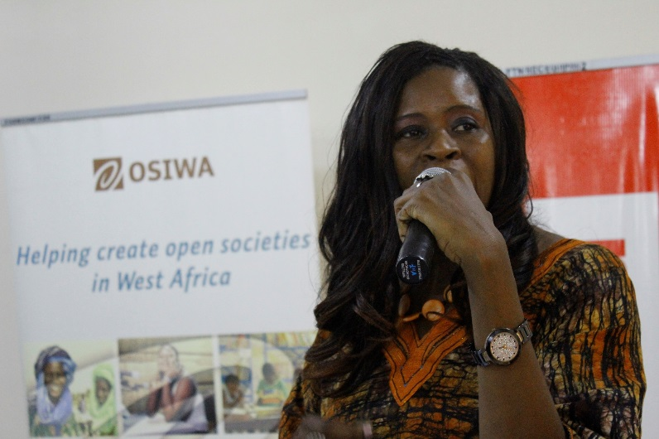**Closing Remarks and Vote of Thanks**

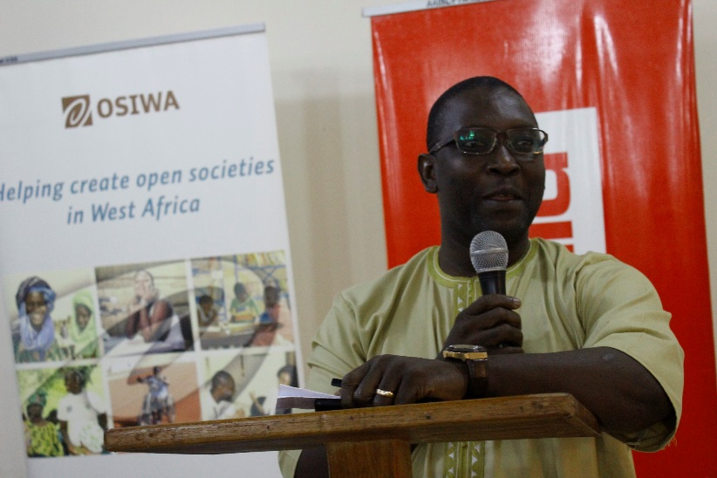The Chair in her closing remarks called on us to think of what solutions could be found, stages we can occupy and be able to question lots of things in the elections process including integrity and expressed hope that all the stakeholders will go along with the project. She called on the artists to speak messages that will resonate with the people. she expressed hope of partnering with AASL on Elections process.

Foday Swaray, Head of programs and Policy, in closing, thanked all the representatives for honoring the ceremony on behalf of the R2R and OSIWA and look forward to their continued support and partnership.

***The launching was climaxed by a live performance by cross section of artist involve in the project including Emmerson Bockarie from Nigeria.***

**INCEPTION MEETING –AFTERNOON SESSION**

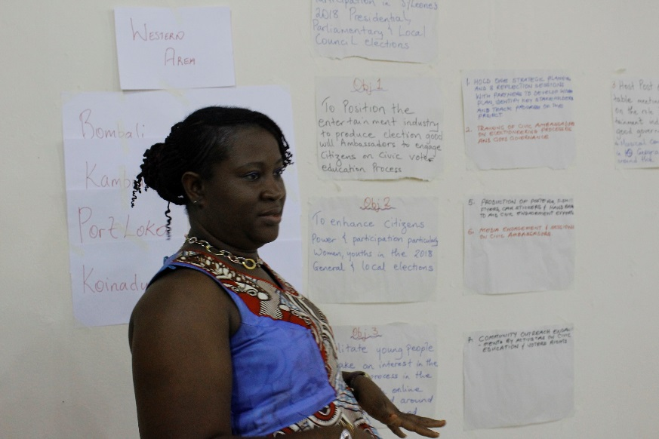Presen**t** at the inception meeting wereactivistas representatives from the 7 ActionAid Local Rights programme, five artists and four ActionAid Staff. *(See attached agenda)*

**Stage setting**: participants introduced themselves and expressed in few words the dream they have for the project.

**Presentation**

The Head of Finance, Mohamed Jaward took participants through:

**ActionAid/OSIWA Grant management Requirement**: what OSIWA funds should be positively used for e.g. education of citizens and areas where the funds should not be used such as influence of legislations, attempt to influence outcome of any specific elections or carry out any registration drive and or to purchase capital equipment’s.

**Record Retention/Audit:** OSIWA’s record retention is for up to 5 years as the organization would be audited.

Conflict of interest: Actions that could be referred to as CA were highlighted:

* Partners should do a proper check of conflict of interest along the grant process e.g. like giving procurement for T-Shirts.
* Participants were informed that that his project will be part of the audit for 2017 since it started in April 2017.
* OSIWA can send for AASL and R2R to be audited and if there are issues of compliance, they will be required to make refunds; thus as partners we should always seek for approval for anything we might want to do that is not in line with the budget.

**Budget Modification:** partners were informed that not more 20% shift could be done between activity lines without approval.

**Matching fund:** are funds that could be received by the partner in addition to OSIWA funding**.**

* Issue of accountability if additional funds are to receive by AASL for the same OSIWA funded project.
* All matching funds should be reported to OSIWA
* Anything to be done outside the scope of the project should need approval from OSIWA.

**General Procurement Requirement:**

* Participants were informed that 90% of the funding is procurement of services or goods.
* That the principle of value for money should be recognized in the implementation process.
* Should be competitive pricing e.g the selected artist as key service providers were accepted based on judgement of the donor and implementers.
* Reminder partners that there is the need for a committee to take decision on all procurements
* Need for a preferred suppliers list for major categories of goods/services – need also to develop and sign MOU’s.

Participants were given the opportunity to ask questions and made comments on issues they found needed clarity.

**Session 2: Demystifying program activities**

Participants were taken though the logical flow of the project from the goal, objectives, activities and outputs and outcomes and the inputs**.**

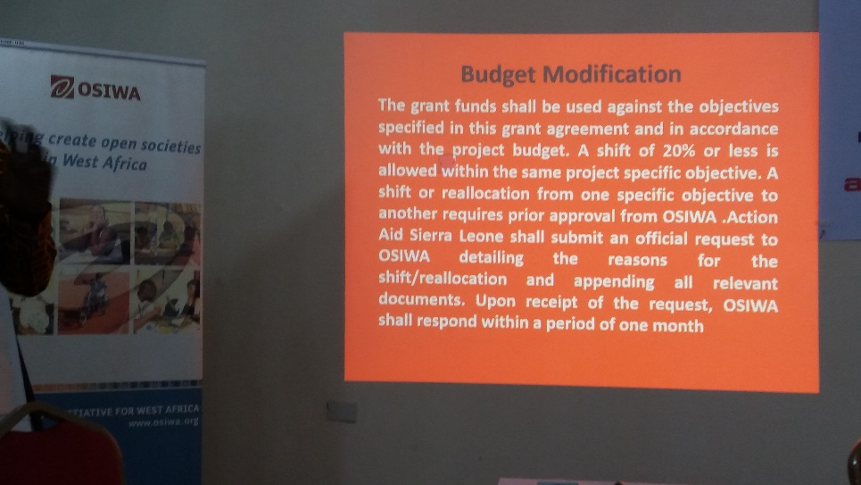

***Presentation on donor requirement at the inception meeting***

**Presentation of the Role of the music in the Democratization process:** this was done by the Campaigns and Communications Coordinator. Participants went through the expectations of the role of artist as follows: to educate, inform the public on voting, preach acceptance of the result when released, and continue holding politicians and government accountable. The Artists were taken through the activities they are expected to contribute to i.e. production of some IEC materials, like songs, jingles and nationwide musical concert.

Activistas went through their own role – which is to mobilizes other youths in their communities on critical issues such as elections – this case engage colleague youths with positive voting messages; community mobilizers with messages of development. They were required to go back and mobilize 20 more activistas per group in each district that would reach out with election messages and encouragement to youth to vote and also facilitate the musical tours and get statistics of voters. Participants were informed that they will be engaged on how the data would be collect, packaged and utilized by them, ActionAid and R@R for civic education and reminder for voting and nonviolence.

**Challenges**

* It was a challenge in getting the artist from the provinces to attend the launch and the inception meeting.

**Recommendation**

* Reel2Real and AASL to ensure that there is a proper blend of rural and urban artist to appeal to the youth audience at both levels.

